HACKATHON

TEAM MEMBERS:

1. ROSHAN.A
2. THRIDEEP.S
3. SUBHIKSHA. R.K
4. ADELINE RAJASELVAM
5. BHUVANA

PROBLEM STATEMENT:

**Quantum Encryption Modules for Secure Satellite Communication**.

The present satellites use traditional cryptographic algorithms for ensuring confidentiality of data. The requirement of employing Quantum Encryption in satellite communication is the need of the hour. The quantum encryption module should be able to support standard data rates of DVB-S2 modems which are typically at 2 to 4 Mbps. The module should be in a plug and play form factor. The module should be able to interface with the existing antenna systems.

ABSTRACT:

A quantum encryption module is a device that uses the principles of quantum mechanics to generate and distribute secure cryptographic keys between two parties. The keys generated by these modules are unbreakable and provide a high level of security for transmitting sensitive data. The use of quantum encryption in satellite communication can significantly enhance the security and privacy of the data transmitted.

OBJECTIVES:

The objective of this is to develop a quantum encryption module for satellite communication, it is important to ensure that it supports standard data rates of DVB-S2 modems, which are typically at 2 to 4 Mbps. The module should be designed to be in a plug and play form factor, which means that it should be easy to install and use with minimal configuration. Additionally, the module should be able to interface with existing antenna systems, which would facilitate easy integration with existing satellite systems.

The design and development of a quantum encryption module for satellite communication would require a team of experts in the field of quantum cryptography, electronics, and satellite communication. The module should undergo rigorous testing to ensure its reliability, efficiency, and compatibility with existing satellite systems. The development process should also consider the power requirements, size, weight, and other practical considerations for space-based applications.

IMPLEMENTATION IN PACKET TRACER:

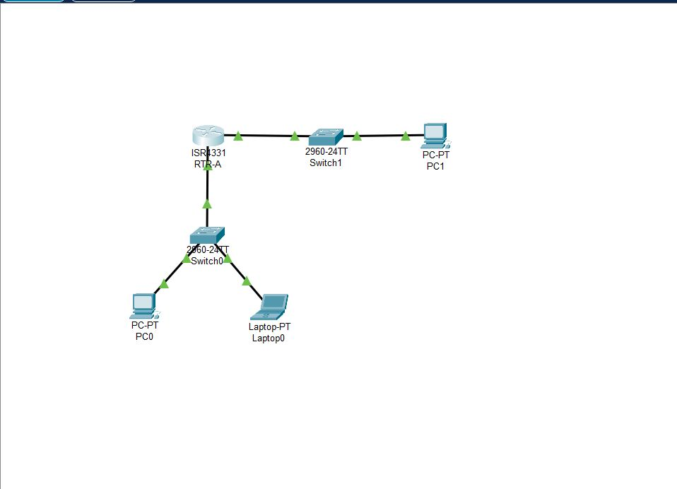

SOLUTION FOR PROBLEM:

The solution for this is the use of quantum encryption modules in satellite communication is an essential step towards ensuring highly secure and reliable communication. The development of a quantum encryption module for satellite communication requires careful consideration of the technical requirements and practical considerations for space-based applications. The module should be designed to support standard data rates, be in a plug and play form factor, and interface with existing antenna systems.